# C:\Users\Messom\Desktop\Monash.jpg

# FIT5042 C/D/HD Design Report (Major Tasks)

# APPLICATION NAME

KeZhang: **29218969**

**Contents Page**

**Your design report must include the following:**

**Credit Level**

1. Overview of your application's goals
2. User stories
3. Functional diagram
4. Usability Design Review
5. Checklist of site functionality.

**Additional Distinction Level (the above and the following)**

1. Entity Relation Diagram
2. Data dictionary

**Additional High Distinction Level (the above and the following)**

1. Development Methodology
2. Versioning

**Your design report must include the following:**

**Credit Level**

1. **Overview** (of your application’s goals)

**This web-application aims to provide a customer management service for the AUSPrintings Pty Ltd. The main goal is to design and develop an web-based interaction system that allow staff manage the customer and customer contact data. This application is developed by JAVA EE and JAVA DB, and it hava a consistend look and feel, and, esay for staff with basic computer skill to manage the data.**

1. **User stories (that are driving your design decisions)**

As a user, I want to change my password, so that I can improve the security in need.

As a user, I want to get a list of all customers, so that I can get a overview of my customers.

As a user, I want to get a detail of one customers, so that I can know his/her information.

As a user, I want to manager my customers, so that I can change these data if my customers changed.

As a user, I want to manager my customer’s contact, so that I can change these data if my customer’s contact changed.

As a manager, I want to change my password, so that I can improve the security in need.

As a manager, I want to get a list of all staff, so that I can get a overview of my staff.

As a manager, I want to get a detail of one staff, so that I can know his/her information.

As a manager, I want to manage the staff information, so that I can change these data if staff changed.

As a manager, I want to manager my staff’s customers, so that I can change these data if my staff’s customers changed.

As a manager, I want to manager my staff’s customer contact, so that I can change these data if my staff’s customer’s contact changed.

As a manager, I want to assign a customer to a user, so that I can change these data if pervious staff leave.

1. **Functional diagram** (illustrating how the core aspects of the program fit together.)

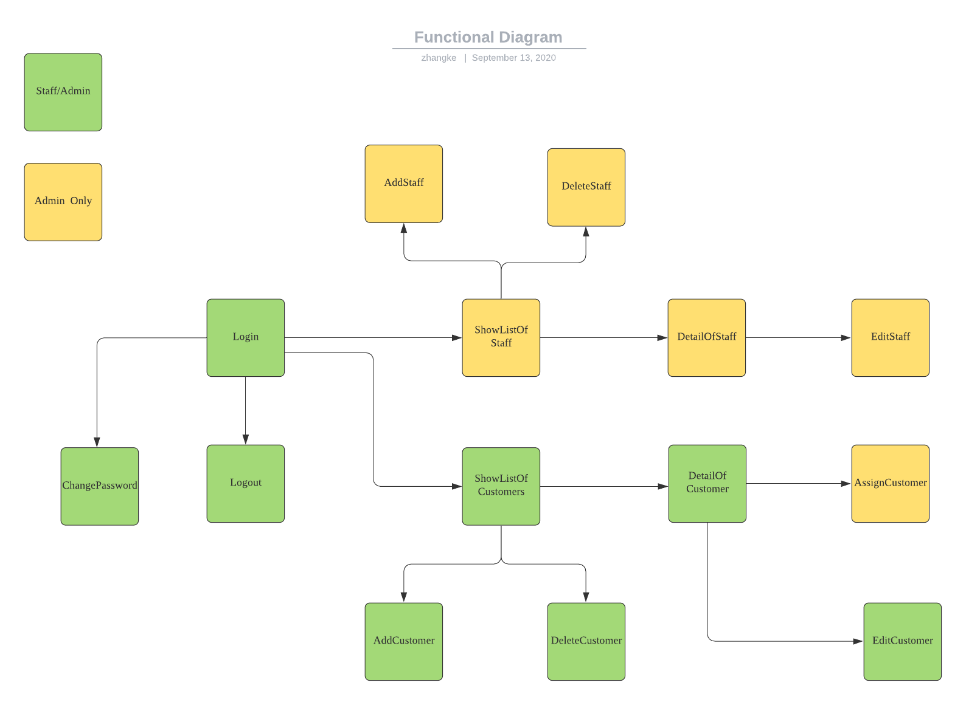

1. **Usability Design Review** (identify usability features built into your design)
2. **Checklist of site functionality**

|  |  |
| --- | --- |
| **1. Credit Functionality** | **TICK**  **if complete** |
| The Web Application must be able to search results of at least two tables |  |
| Results with tabular format with heading. |  |
| Option to view the full details |  |
| CRUD features as required |  |
| Validations in place |  |
|  |  |
| **2. Distinction Functionality** |  |
| CRUD features as required |  |
| Normal users can change their own password |  |
| Admin can also view, add, update and delete type of industry and normal users |  |
| Admin can assign a Customer to a user |  |
| Implementation of validations for Dates, emails, phone numbers, two passwords same |  |
|  |  |
| **3. High Distinction Functionality** |  |
| Search for data in tables using a combination of fields |  |
| use of a RESTful Web Service in your application |  |
| Make use of some features from javaScript framework / Ajax |  |
|  |  |
| **4. Technical Requirements** |  |
| **Credit** |  |
| JSF web clients |  |
| Persistence API |  |
| Application managed entity manager or container managed entity manager. |  |
| JPQL to retrieve data |  |
| Use of Git repository |  |
| **Distinction** |  |
| Web client is required |  |
| BOTH Criteria API and JPQL |  |
| Role based authentication (implemented using JAAS) |  |
| Interaction between clients and database handled by EJBs |  |
| **High Distinction** |  |
| use of a RESTful Web Service in your application |  |
| Use of JavaScript Frameworks / Ajax |  |
| Ability of mapping inheritance to database must be demonstrated. |  |
| Bean validations used to validate data. |  |
| Consumption of web services conducted in EJBs. |  |
|  |  |
| **Audit** |  |
| No breaking of copyright |  |

**Additional Distinction Level (the above and the following)**

1. **Entity Relation Diagram**

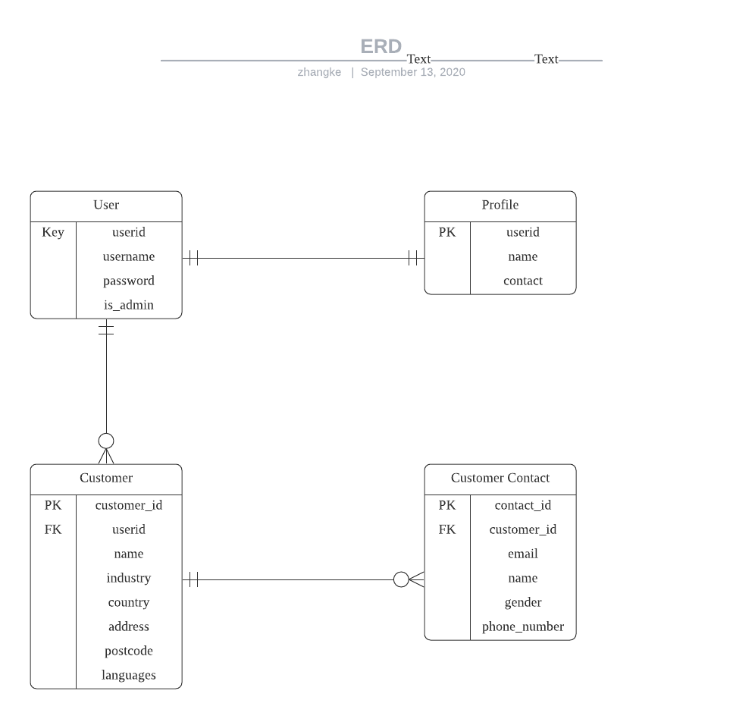

1. **Data dictionary** (of your application, including the main data structures and types used in your application.)

**Additional High Distinction Level (the above and the following)**

1. **Development Methodology**
2. **Versioning**